Here are instructions for getting Promotion and Tenure evaluation data out of New Innovations.

# Assistance

Call Alex Dompe for assistance if you have any difficulty or questions.

__Description: Description: Description: Description: Description: cid:image001.gif@01CBFB52.48D882F0__

Alex Dompe  
Data Management Analyst  
Office of Medical Education  
UF College of Medicine  
[adompe3@ufl.edu](mailto:adompe3@ufl.edu)  
(352)294-8654

# The Data Source

The main source of data comes from New Innovations Evaluation Reports and is limited to the number of times the faculty was evaluated, the average score per question for the faculty, and the overall average score for per question during the semester.

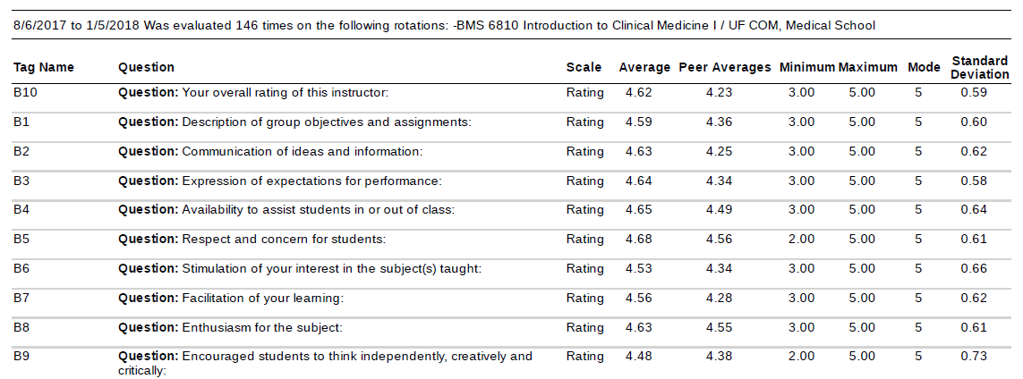

# Locating the Evaluations

To locate the evaluating departments for a faculty member, log in to New Innovations and go to the Medical School department using the dropdown in the upper right corner.



From Medical School, you can run a report on a faculty member to see which departments conducted an evaluation on them.

Open Evaluations > Reports and use the calendar icon on the right of the screen to enter a date range.

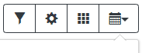

Enter the date range of all the semesters needed for the Promotion and Tenure report.

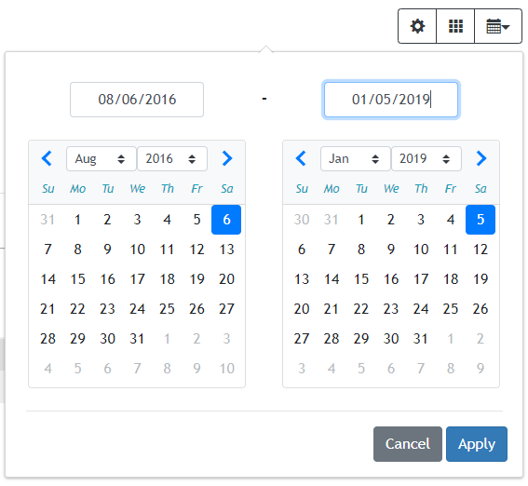

Once the date range is set, click on the Action button to the right of Faculty Reports and click View.

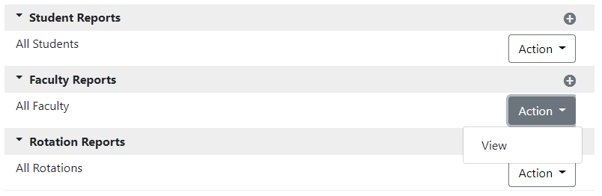

Use the spyglass button to search for the faculty member.

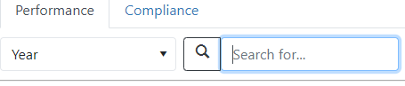

Take note of each department that has instructor evaluations for the faculty. In the next step, you will visit these departments to extract your reports.

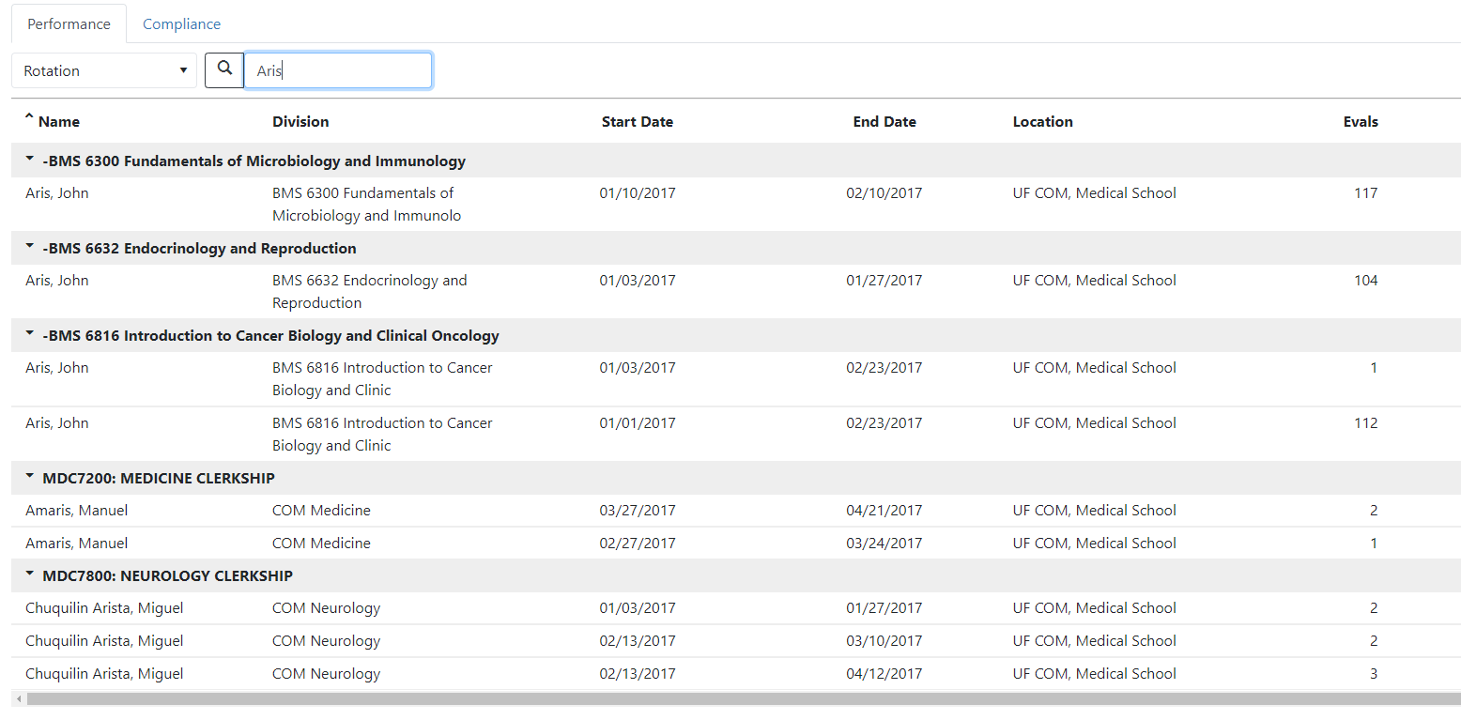

# Downloading the Reports

Go to each department to collect the evaluation data.



Go to Evaluations > Reports and collect the data for the semester by using the calendar icon to set the date range.

Because our courses do not follow the UF semesters system, there is no perfect way to get all of the evaluations for a given semester, so one recommendation is to use back-to-back cutoff dates so that no evaluation overlaps or goes uncounted. Below is a suggested block of dates for the 2017 – 2018 academic year.

* 2017 Fall: 8/6/2017 – 1/5/2018
* 2018 Spring: 1/6/2018 – 5/5/2018
* 2018 Summer: 5/6/2018 – 8/5/2018

This is the date range set for Fall 2018.

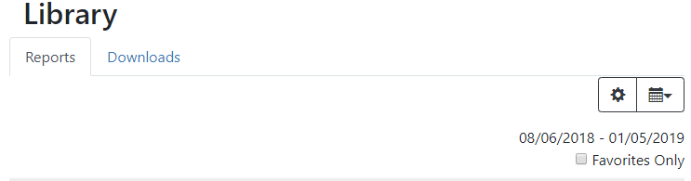

After the semester’s date range has been set, click on Action then View next to Faculty Reports.



The faculty’s image will appear on their faculty evaluation page. Click on the Responses tab below the image and check Show Hi/Lo Scores. Do not check Scoring Details, Identify Evaluators, or Show Comments. Click on the angled arrow and select Export PDF.

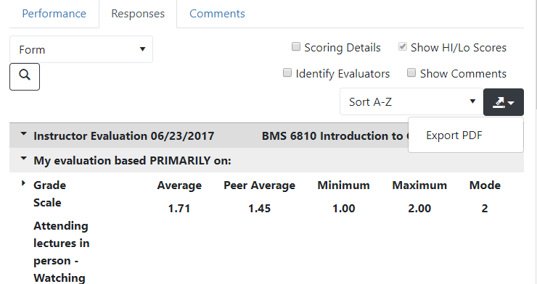

A pop-up window will appear for the selection of the Export Details. Be sure to check only the Responses by Tag box. Then click Export.

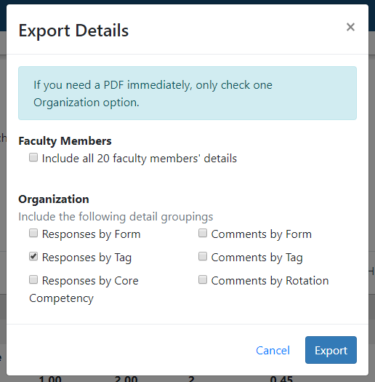

The report will be downloaded to the location of your choice as a PDF document. Use Adobe Acrobat Pro DC to convert the document to Word or clip an image from the PDF for your report. Repeat the process for all of the other departments and semesters.

