PROMOTION, TENURE, & PERMANENT STATUS
TEMPLATE 2022-23

Please delete this text box after completing this section
*You will want to delete all of the directions/notes and leave the numbered bold header and related content.

This template must be used by all candidates for promotion, tenure or permanent status.
Please fill in the template with appropriate information related to promotion, tenure, and/or permanent status nominations. Note that some sections will auto-populate with available data from several University sources; you must verify accuracy as indicated. Once all sections are filled in, you may delete the explanatory information in the template, including this page, prior to saving as a PDF file to uploading into the OPT system.
The template includes guidelines on specific content for those portions of the packet that are not auto-populated. All items in the packet must have the materials in the same order and titled as shown. Items should be listed in reverse chronological order. If a category does not apply, please write “N/A” by that heading; if you have nothing to report, use “None.” Information should cover your professional career, unless otherwise noted.
The final version of your packet should contain only those things specifically required in this template or noted in the “Guidelines and Information Regarding the Tenure, Permanent Status and Promotion Process” available online at http://www.aa.ufl.edu/tenure .
Once completed, the template must be uploaded into the Online Promotion and Tenure (OPT) system as a PDF file. Once uploaded, any changes that need to be made on the template will require that it be saved again as a PDF and uploaded again. You may repeat the upload process as many times as necessary, until the packet has been certified. Your departmental or unit OPT administrator will work with you on certification. (A list of all departmental OPT administrators can be found at https://uflorida.sharepoint.com/sites/aa/Provost/PT/Lists/PTAdmins/AllItems.aspx)
After the packet is certified, you may not make changes to the information in your packet, but any changes or additions must be uploaded into Section 34 (Further Information) as PDF files. You may upload additional documents beyond those required by the template and “Guidelines” as PDF files into Section 34. Note that such documents should be limited in number and scope. For information on how to create and manage PDF files, you may contact the UF Help Desk at 352-392-4357.
Supporting materials (copies of articles, books, electronic media, etc.) should be made available through your departmental or unit office. Do not upload these materials into the template or the OPT system.
NOTE: You are responsible for the completeness and accuracy of all materials in the online packet, including any auto-populated sections. Please be sure to check the accuracy of the information in your packet.
1. NOMINEE INFORMATION COVER SHEET

Please delete this text box after completing this section
This section will auto-populate in the OPT system on a separate Cover Sheet; it is the candidate’s responsibility to check the information that appears on the Cover Sheet for accuracy. If you find a discrepancy, contact your Departmental OPT Administrator or Faculty Relations (opt@admin.ufl.edu).

2. BRIEF DESCRIPTION OF JOB DUTIES

Please delete this text box after completing this section
Briefly describe your assigned duties and responsibilities. Provide context for these responsibilities (ie. the relevance and importance to your discipline and UF)

* For sections 2 and 3 use first person. Paragraph preferred (vs. list).

*Tell which mission(s) you have attained excellence.

*You must attain excellence in your primary mission area.

*Be explicit, “I am a clinical assistant professor of pediatrics in the division of general pediatrics and I have achieved distinction in the educational mission.”

*Address all missions and note here any gaps in assignment or < 100% FTE.

*If recently coming from another institution, tell us what you did there (briefly)

*Two areas of excellence required for tenure, one (primary) required for MM, but also tell us about your other responsibilities.

Tell your story – which will be supported by the rest of the packet.

No more than 1 -1.5 pages for both sections 2 & 3, ok to be less.

- Impact of COVID pandemic on Job Duties.
Please delete this text box after completing this section
This section is optional. In this optional section faculty may provide statement regarding the impact of the COVID-19 pandemic on the nominee’s professional life -- up to 500 words. This statement should explain how the nominee adjusted/compensated for pandemic related difficulties impacting their research, teaching, clinics, extension or service. Please see http://aa.ufl.edu/policies/tenure-and-promotion-information/ for more details.

3. AREAS OF SPECIALIZATION

Please delete this text box after completing this section
Briefly describe your assigned duties and responsibilities. Provide context for these Briefly describe your area(s) of specialization. Please frame your specialty within the context of your discipline and the mission of your unit(s) and UF.

4. EFFORT REPORTED SINCE LAST PROMOTION (NOT TO EXCEED TEN YEARS), OR SINCE UF EMPLOYMENT, whichever is more recent

Please delete this text box after completing this section
*Populated assignments can updated to reflect accurate percentages but the table format must not be altered. Make sure that the percentages for each term/year equal 100%.
This is where you are spending your time, not sources of your salary.

This section will auto-populate from your record in the Effort Reporting System starting with 2011. If you were employed or promoted at UF prior to 2011, please add your approximate effort into the chart for the earlier years, following the established reporting for effort (see http://hr.ufl.edu/wp-content/uploads/instructionguides/EffortReportingActivityCategories.pdf).

*Applicants with two primary appointments must consolidate the assignments in one effort table to show proportional activity across both appointments. For example: an applicant with two 0.50 FTE appointments who has a 100% research assignment in one and a 0% research assignment in the other, will report a 50% research assignment.

*Note: overload assignments are not reported in the promotion packet.

*If you have questions about the effort reported, contact your unit effort reporting coordinator.

*If you are being considered for tenure or permanent status and were hired during this current academic year, also include assigned activity for the current year at UF.

The chair’s/director’s letter should provide an explanation of any significant changes in assignment.

Department
Term/Year | Teaching | Research | Service | Extension | Clinical | Sabbatical | Leave | Other | Total

5. EDUCATIONAL BACKGROUND

Please delete this text box after completing this section
This section will auto-populate from your record in the UFHR database; it is the candidate’s responsibility to check for accuracy. If you find a discrepancy, contact Faculty Relations at opt@admin.ufl.eduIf any corrections are made in the UFHR database, you will need to save and reload the template again as a PDF file.

*HR only maintains faculty degree information such as Master’s, Bachelor’s, PhD, MD, JD, and other academic or professional degrees. Fellowship, residency, and post doctoral information, must be added in Section 5 of the OPT template word document by the candidate/faculty member.

Institution | Field of Study | Degree | Year

6. EMPLOYMENT

Please delete this text box after completing this section
*Please use the word “Clinical or Research” in front of the rank for non-tenured faculty positions. Tenure track or non-tenure track should be listed for each position. List rank and Administrative positions.

List your employment history, with UF employment appearing first. Please show employer, ranks and administrative positions you held at each place of employment, effective dates of each title and whether or not the position was tenured, tenure-accruing, or non-tenure-accruing if employment was with an institution of higher education. Affiliate, joint, courtesy appointments should be listed in section 20.

Institution | Position | Dates

7. YEAR TENURE/PERMANENT STATUS WAS AWARDED BY UNIVERSITY OF FLORIDA

Please delete this text box after completing this section
This section will auto-populate from your record in the UFHR database; it is the candidate’s responsibility to check for accuracy. If you find a discrepancy, contact Faculty Relations at opt@admin.ufl.edu. If any corrections are made in the UFHR database, you will need to save and reload the template again as a PDF file.

8. TENURE AND PROMOTION CRITERIA

Please delete this text box after completing this section
To be uploaded in OPT system by department administrator. It is the candidate’s responsibility to provide appropriate notice and to check for accuracy of the criteria in her or his case.

Candidates note: If your department’s tenure, permanent status, or promotion criteria have changed during your probationary period or since your last promotion, you may need to provide notice to your chair as to which criteria should be used for your review. The notice period varies across the University, so check with your chair for requirements.

*This section will be uploaded separately in OPT and should not be inserted into the packet. The COM guidelines can be located via the following link: https://facultyaffairs.med.ufl.edu/faculty-resources/tenure-promotion/2012-2013-com-guidelines-new/ (only insert sections from the guidelines that apply to your rank and areas you are seeking excellence in).

9. TEACHING, ADVISING, AND INSTRUCTIONAL ACCOMPLISHMENTS

Please delete this text box after completing this section
In no more than 750 words, describe your teaching, advising, professional responsibilities (Librarians), and/or instructional accomplishments. Provide context for these responsibilities (ie. the relevance and importance to your discipline and UF), a brief statement of your teaching philosophy and how it is supported by your activities, and the primary educational goals and outcomes of your teaching program. Include, as appropriate, curriculum and course development, service as a graduate or undergraduate coordinator, supervised research through credit courses, and the development of new courses, educational software and multimedia materials.

Undergraduate instructional activities may include supervision of honors theses and research projects.
Syllabi, course examinations and other materials used in classroom instruction should be made available at all levels for review as needed or requested. However, they should not be included in the packet (except for those cases covered in Section 11).

10. TEACHING EVALUATIONS
A.
Please delete this text box after completing this section
UF teaching evaluations for the past 10 years will auto-populate in this section. For cases involving only promotion, include evaluations only since your last promotion not to exceed ten years. In the box provided for each course, you must indicate whether or not the course was team-taught (and the percentage for which you were responsible), the mode of delivery (classroom, online, distance learning context,) and whether the course was required.

(Required courses are General Education courses, or those required for a particular major.) If you have any questions as to the accuracy or completeness of the data, send a query to evaluations@ufl.edu and GatorEvals-Support@ufl.edu. Any inaccuracies must be corrected in the database in order for them to be permanent. If any corrections are made in the Evaluation database, you will need to save and reload the template again as a PDF file. The University process does not require a summary of all teaching evaluations. If your college does require a summary, it can be entered in this section. NOTE: The departmental and college means are calculated using only either undergraduate or graduate courses, depending on the level of the course being evaluated.

In cases where the number of responses is greater than the number enrolled, provide a footnote explanation.

If teaching evaluations completed during the last five years from other institutions are available, you may include them in Section 33.
If this is your first year of employment and you have a teaching assignment, then you will be evaluated during the fall term. You may upload those statistics into Section 33 when they are available.

Summary Table
Course | Term | Enroll  # | Req  yes/no | Candidate Overall |  | Department Overall |  | College  Overall
 |  |  |  | Instructor | Course | Instructor | Course | Instructor | Course

Term: , Course: , Sections: Enrolled:
Required Course: Team Taught %: Mode of Delivery:
Questions | Responded | Response Rate | Mean | IM | Dept  Mean | Dept  IM | College  Mean | College  IM
The instructor was enthusiastic about the course. |  | %
The instructor explained material clearly and in a way that enhanced my understanding.
The instructor maintained clear standards for response and availability (e.g. turnaround time for email, office hours, etc.)
The instructor fostered a positive learning environment that engaged students.

The instructor provided prompt and meaningful feedback on my work and performance in the course.
The instructor was instrumental to my learning in the course.
Course content (e.g., readings, activities, assignments) was relevant & useful.
The course fostered regular interaction between student and instructor.
Course activities and assignments improved my ability to analyze, solve problems, and/or think critically.
Overall, this course was a valuable educational experience.

Please delete this text box after completing this section
*None of the teaching evaluations from New Innovations will auto-populate only those who have registered courses. Therefore, it would be helpful if you could format the new innovations material into charts like the example above.

*Please be sure to indicate and list whether or not it was Team Taught

*Please be sure to indicate whether or not it was a required course.

*In cases where the number of responses is greater than the number enrolled, provide a footnote explanation

Please use the heading below (or something similar) if adding resident evaluations.
Resident Evaluations

Generating Faculty Evaluation Summary for P&T Packet
(Only applies to resident/fellow & PA student evaluations of faculty.)

Please contact you Department/Division program coordinator to generate these reports for you.

- Go to Evaluations > Reports
- Click the Overall Tab
- Click the Dropdown for date select Academic Year to generate reports by Academic Year. You can also choose Custom and generate a cumulative report.
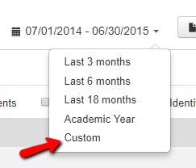

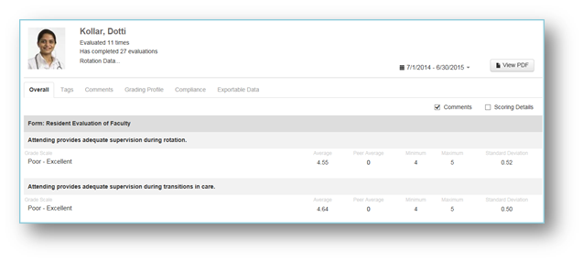
When you click view PDF, you will have the option to generate multiple faculty reports by selecting the appropriate checkbox. These reports will be e-mailed to you. Each person’s report will come in an individual email, so they can be forwarded to the appropriate person.

If your coordinators are having difficulty generating these reports, please have them contact Sony Kuruppacherry.
E-mail- kurupsj@ufl.edu
Phone – 394-5314

Please delete this text box after completing this section
How to get Promotion and Tenure data from New Innovations Medical Student Evaluations

Here are instructions for getting Promotion and Tenure evaluation data out of New Innovations.

Assistance
Call Alex Dompe for assistance if you have any difficulty or questions._
Alex Dompe
Data Management Analyst
adompe3@ufl.edu
(352)294-8654

The Data Source
The main source of data comes from New Innovations Evaluation Reports and is limited to the number of times the faculty was evaluated, the average score per question for the faculty, and the overall average score for per question during the semester.
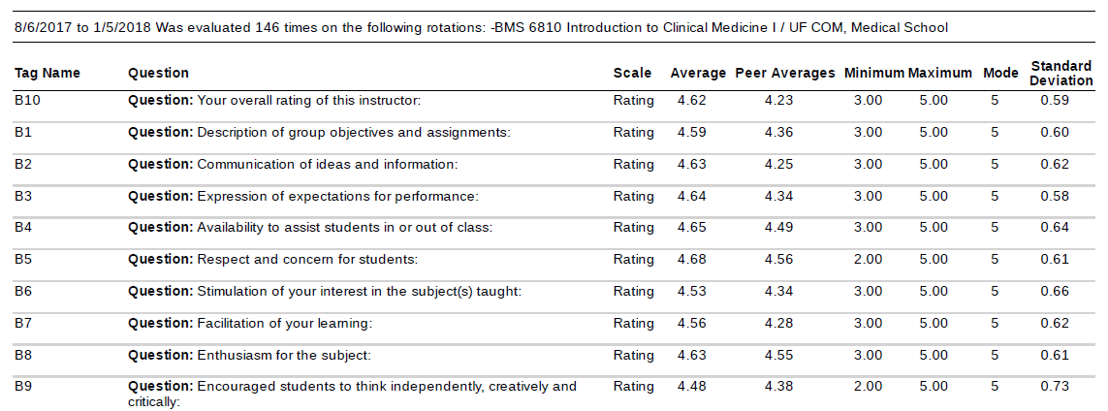

Locating the Evaluations
To locate the evaluating departments for a faculty member, log in to New Innovations and go to the Medical School department using the dropdown in the upper right corner.

From Medical School, you can run a report on a faculty member to see which departments conducted an evaluation on them.

Open Evaluations > Reports and use the calendar icon on the right of the screen to enter a date range.
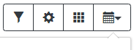

Enter the date range of all the semesters needed for the Promotion and Tenure report.
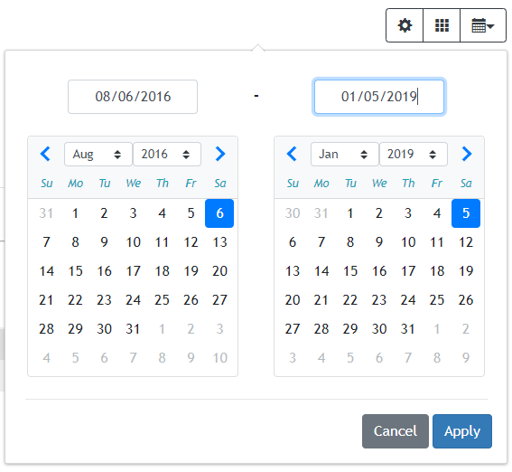

Once the date range is set, click on the Action button to the right of Faculty Reports and click View.
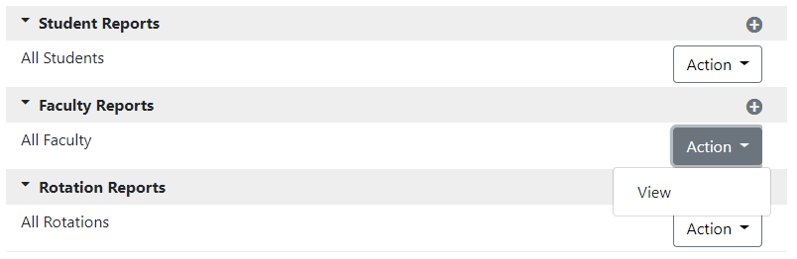

Use the spyglass button to search for the faculty member.
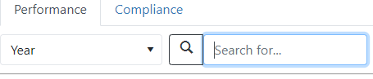

Take note of each department that has instructor evaluations for the faculty. In the next step, you will visit these departments to extract your reports.

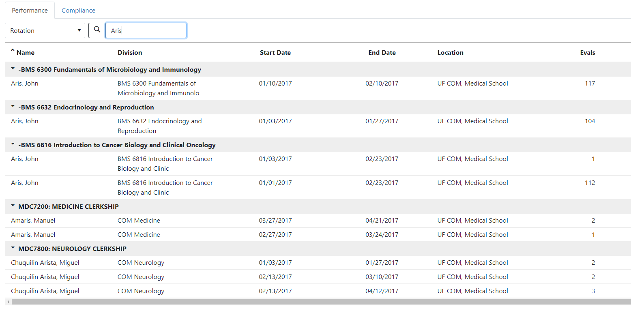

Downloading the Reports
Go to each department to collect the evaluation data.
Go to Evaluations > Reports and collect the data for the semester by using the calendar icon to set the date range.
Because our courses do not follow the UF semesters system, there is no perfect way to get all of the evaluations for a given semester, so one recommendation is to use back-to-back cutoff dates so that no evaluation overlaps or goes uncounted. Below is a suggested block of dates for the 2017 – 2018 academic year.
- 2017 Fall: 8/6/2017 – 1/5/2018
- 2018 Spring: 1/6/2018 – 5/5/2018
- 2018 Summer: 5/6/2018 – 8/5/2018

This is the date range set for Fall 2018.

After the semester’s date range has been set, click on Action then View next to Faculty Reports.
The faculty’s image will appear on their faculty evaluation page. Click on the Responses tab below the image and check Show Hi/Lo Scores. Do not check Scoring Details, Identify Evaluators, or Show Comments. Click on the angled arrow and select Export PDF.

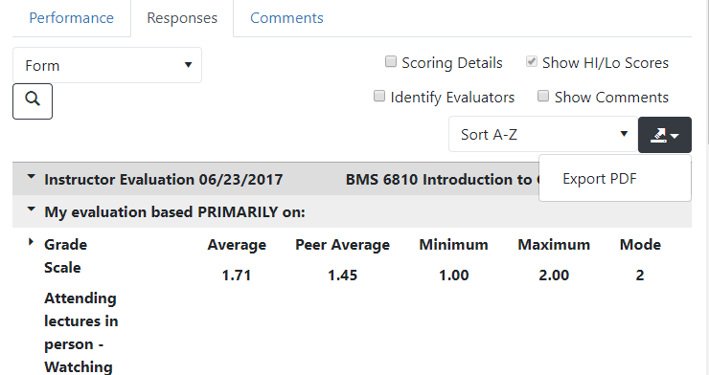

A pop-up window will appear for the selection of the Export Details. Be sure to check only the Responses by Tag box. Then click Export.

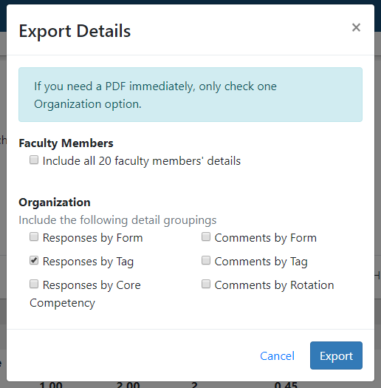

The report will be downloaded to the location of your choice as a PDF document. Use Adobe Acrobat Pro DC to convert the document to Word or clip an image from the PDF for your report. Repeat the process for all of the other departments and semesters.

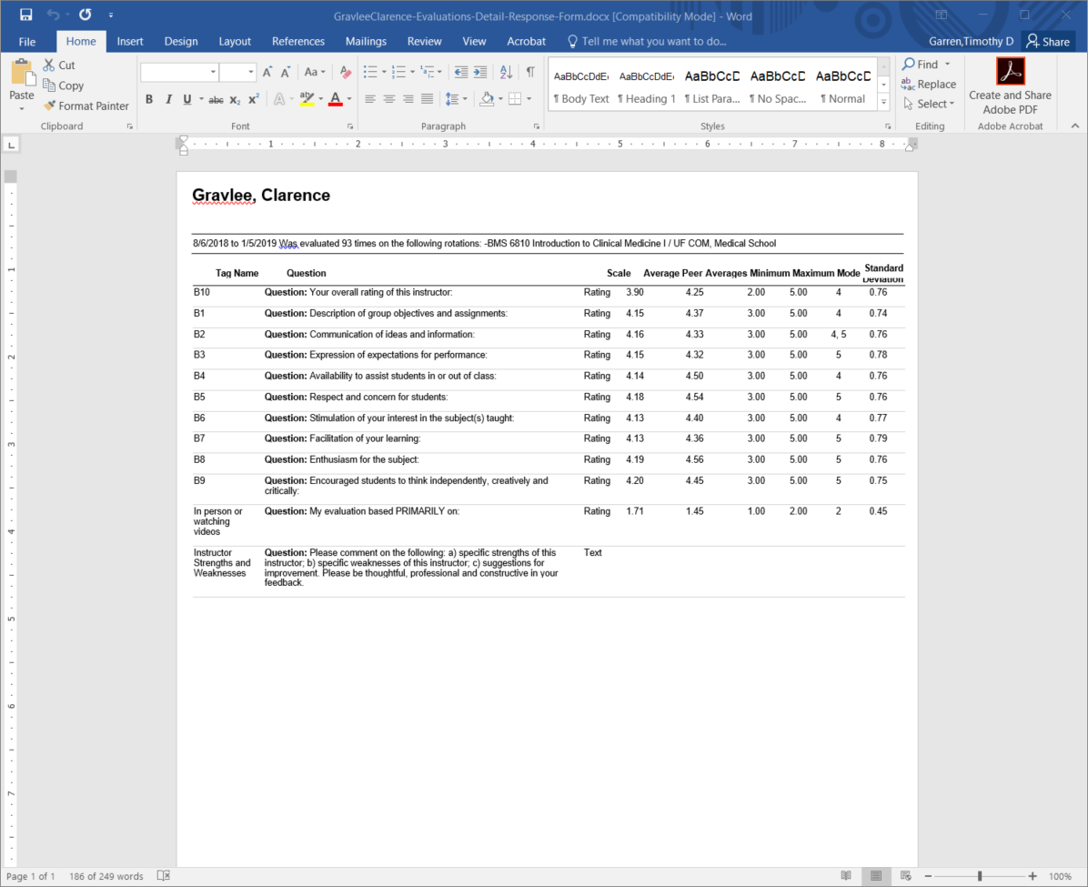

B. Peer assessments should be included here, if available.

Please delete this text box after completing this section
*The Peer Evaluations for Teaching Template is located via the following link: http://facultyaffairs.med.ufl.edu/faculty-resources/tenure-promotion/2012-2013-com-guidelines-new/peer-evaluation-forms-2/

11. EDUCATIONAL PORTFOLIO (if applicable)

Please delete this text box after completing this section
This section is for those units where faculty are expected to develop portfolios in which they document excellence in educational scholarship, leadership and service. If you are in one of these units, include a summary of the recommended portfolio, if available. The full portfolio should be available off-line and may be requested for review.

Faculty such as Lecturers whose primary assignment is in teaching and service should include in this section illustrative examples of materials that document the instructional accomplishments described in Section 9. Examples may include sample exams, excerpts from syllabi, and any evidence of teaching effectiveness. Select sample materials carefully: the quality of the materials is more important than their quantity.

Educational Portfolio, College of Medicine Template
The five headings listed below are designed to provide candidates with the opportunity to document their achievement of distinction in teaching/education. Include all elements that are relevant. You do not need to list items which are not applicable to your circumstances. This segment is not intended to duplicate other aspects of the packet, but to enhance and expand the descriptions of your educational accomplishments. You may also indicate “see Educational Portfolio” for relevant referencing within your description of accomplishments in Section #9 (Teaching, Advising, and Instructional Accomplishments). However, you should not avoid completion of a thoughtful response to Section #9. The quality of the elements included in this portfolio is more important that quantity. Please keep to a limit of 12 pages for the entire portfolio. You may include selected illustrative examples of course syllabi, assessment tools, novel instructional media, etc. in this portfolio (#3f). Instructions (in italics) may be deleted from the completed portfolio.

1. Instructional Activities and Evaluations.
Please delete this text box after completing this section
List all your instructional activities since hire, or since your last promotion – whichever is applicable -- under the applicable categories. If any are recurring activities, list once and indicate the number of times or years you have performed the role(s).

a. Teaching Activities and Evaluations.
i. Course Director
Please delete this text box after completing this section
(indicate if for the College of Medicine, Graduate School, undergraduate course. Provide course number and title. Semester and year(s) you were course director.
ii. Lectures within Courses
Please delete this text box after completing this section
(lecture title, course name and number, semester and year(s) provided)

iii. Lectures in other forums

Please delete this text box after completing this section
(indicate lecture title and venue, dates, location – if not onsite. CME course can be included here.)

iv. Small group and seminar sessions led
Please delete this text box after completing this section
(provide course name, frequency of meetings, semester and years(s).

v. Clinical teaching of professional students
Please delete this text box after completing this section
(medical students, nursing students, PA students, etc.) Provide a description of setting, type of trainee, frequency of contact, number of trainees for each rotation. Indicate the number of weeks or months for each academic year you serve as clinical instructor.

vi. Clinical teaching of residents or fellows.
Please delete this text box after completing this section
Provide a description of setting, type of trainee, frequency of contact, number of trainees for each rotation. Indicate the number of weeks or months for each academic year you serve as clinical instructor. Provide estimates if exact figures are not available. E.g. “I had an average of two [specialty] residents on my service for 3 weeks at a time over 4 months of the year.”

2. Educational materials.

Please delete this text box after completing this section
Describe new and revised syllabi, assessment tools, video and on-line instruction, simulation methods, and others. Enter illustrative examples in this section, if relevant
  - Course development
  - Curriculum development
  - In person, one on one education or course series
  - Workshop
e. Peer review activities related to educational scholarship.
3. Educational Leadership/Recognition
a. Major educational Responsibilities.
Please delete this text box after completing this section
Indicate role, title, and inclusive dates (e.g. clerkship director, program director, residency director, vice chair for education, assistant dean, etc.)

4. Mentorship.

Please delete this text box after completing this section
Describe individuals and groups mentored by category below. Indicate, if available, the achievements and accomplishments of mentees. List any individual research mentees. Describe any group mentees, e.g. residency interest groups.

  - Faculty Include scholarly mentoring of junior faculty, participation in peer evaluation, etc.
b. Residents and fellows
c. Students
d. Post-doctoral fellows
5. Letter from an education supervisor.
Please delete this text box after completing this section
Insert a narrative from the relevant supervisor (residency program director, course director, department chair, Associate Dean for Education, etc.) documenting your performance in your teaching role. Include the scope of teaching, evidence of creativity, highlights or major accomplishments, use of novel and varied pedagogical methods, and responsiveness to feedback regarding teaching skills.

12. GRADUATE COMMITTEE ACTIVITIES

Please delete this text box after completing this section
This section will auto-populate from Graduate Information Management System (GIMS) information; it is the candidate’s responsibility to check for accuracy. To update your committee information please contact your departmental staff. You will need to reload the template as a PDF file after updates are made in the GIMS database. If you find an error or discrepancy, contact the Graduate School at graddata@ufl.edu. You may also indicate with an asterisk on your role that a Master’s committee was a non-thesis option. For active committees please indicate the anticipated completion date.

Candidate’s Role | Student | Major | Complete Date

13. CONTRIBUTION TO DISCIPLINE/RESEARCH NARRATIVE

Please delete this text box after completing this section
In no more than 750 words explain your research/creative contribution to your discipline. Describe briefly the overall area within which your research/creative program falls and how your publications, creative work, research projects, grants, fellowships, extension works, etc., reflect your research/creative program and your achievements. There is no need to cite specific works or grants listed elsewhere in the packet. Simply reference works published, exhibited, or supported by various sources. Please address the quality of the journals in which you publish and the impact of your research/creative program. Please characterize the nature and extent of your contributions to major publications of which you are not the sole author or senior/principal author.

14. CREATIVE WORKS OR ACTIVITIES

Please delete this text box after completing this section
This area should be used to list exhibitions, concerts, performances, commissioned works, audio/visual materials developed, software written, cultivars developed, or other similar creative works, including dates. Include published critical reviews of these creative works in this section. Create a subheading for PowerPoint presentations, if applicable. Refer to instructional and informational presentations that may be delivered numerous times as “Instructional Multimedia Presentations” rather than “PowerPoint Presentations.” Do not list individually, but summarize for each year. Create a subheading for publications developed in support of web based communication and teaching, such as Webinars, if applicable.

15. PATENTS AND COPYRIGHTS

Please delete this text box after completing this section
Include date(s) with each item and give an indication of the significance of its (their) contribution to the profession/discipline. NOTE: If you have entered your patents and copyrights in this OPT self-service module, they will auto-populate in this section.

16. PUBLICATIONS

Please use the following “key” to indicate author relationships:

Senior/principal author(s) = Underline
Self = bold
Fellow = f
Graduate Student = g
Other = &
Post-Doctoral Associate/Fellow = p
Resident = r

Please delete this text box after completing this section
The citation format is your choice, but entries should contain the information requested. Please include the names of all authors. Include all subcategories and if there are no entries, write “None.” Put EDIS publications in a separate section under “g. Non-refereed Publications.” Indicate that they are peer-reviewed and provide the URL. NOTE: If you have entered your publications in this OPT self-service module, they will auto-populate in this section.

*Do not delete the publications key, please still delete the instructions above.

*You should use the on-line publication tool for this section-Publications will format into the online template and you can then cut and paste that section back into your main working document.

*You will want to include all sections numbers etc. and place the word “None” if the faculty member does not have any information to provide.

*You should number each section starting with number 1.

*Use Section 34 for acceptance letters and information on submitted or forthcoming publications.

*Books that are under contract but have not yet been completed or accepted for publication are to be listed in Section 34. (Note that a contract from a publisher is not sufficient to claim a book is “accepted” or “in press.”)

Do not include theses and dissertations in the publication listing.

The following information should be considered when compiling the publication listing:

(1) Refereed Journals: A paper is considered “refereed” if it appears in a journal (or proceedings) whose papers are published only after review and acceptance by one or more independent professional expert(s) of national or international standing.

(2) Refereed Proceedings: Should be listed as a separate category under Refereed Publications, and the nominee should provide a brief explanation of the review process for the proceedings. This may be entered as a footnote to the publication list.

(3) Non-refereed Publications: Materials listed under non-refereed publications should include not only those journal articles that have not been refereed, but also extension publications delivered in print or via electronic format, and electronic bulletins.

(4) When listing publications, please do not use the term “forthcoming.” Use one of the following:

(a) Accepted: A publication is defined as accepted if it has been finally accepted for publication by an editorial board or similar entity empowered to authorize publication, and will appear in print in the future.

(b) In press: A publication is defined as in press if it has been accepted for publication and has been copy-edited, or otherwise made ready for publication at a date certain.

If a publication is listed as “accepted” or “in press” in Section 16, a copy of the letter of acceptance must be included as a PDF in Section 33. Please include the name of the article on the acceptance, if it is not already stated, and indicate the approximate length of the publication in the citation.

(c) Submitted: The term “submitted” refers to a manuscript that has been submitted to a publisher for publication review. Submitted publications are to be listed in Section 33 rather than Section 16. If the publication is still in the writing stage, please do not include it in the packet. Books that are under contract but have not yet been completed or accepted for publication are to be listed in Section 33.

(5) Graduate students, post-docs, residents, fellows and interns listed as authors should be identified using the key.

(6) Be sure that pagination is listed. If an article is longer than one page, give first and last page numbers.

(7) Media releases are considered “Miscellaneous” publications.

(8) “Reviews” refers to reviews written by you about someone else’s work. Reviews of your work, if included, should be listed in Section 14 or Section 33.

(9) Publication citations of works written in a foreign language should be accompanied by an English translation in parentheses.

(10) All publications must appear in one of the categories provided.

(11) Do not include theses and dissertations in the publication listing.

(12) Online publications require a letter from the publisher (upload as PDF into Section 33) unless the publication can be accessed via a URL.

*Please delete italicized instructions.

Categories:
a. Books, Sole Author (Title, Publisher, Place of Publication, Date, Inclusive Pages)

b. Books, Co-authored (Co-author(s), Title, Publisher, Place of Publication, Date, Inclusive Pages)

c. Books, Edited (Editor, Co-editor(s), Title, Publisher, Place of Publication, Date, Inclusive Pages)

d. Books, Contributor of Chapter(s) (Author, Co-author(s), Title of Book and Chapter, Publisher, Place of Publication, Date, Inclusive Pages)

e. Monographs (Author, Co-author(s), Title, Series of Volume, if applicable, Publisher, Place of Publication, Date, Inclusive Pages)

f. Refereed Publications (Author, Co-author(s), Title, Name of Journal or Publication, Volume, Date, Inclusive Pages)

g. Non-refereed Publications (Author, Co-author(s), Title, Name of Journal, Bulletin, Circular, or other Publication, Volume, Date, Inclusive Pages)

h. Bibliographies/Catalogs (Author, Co-author(s), Title, Publisher, Place of Publication, Date, Inclusive Pages)

i. Abstracts (Author, Co-author(s), Title, Name of Journal or Publication, Volume, Date, Inclusive Pages)

j. Reviews (Author, Co-author(s), Title and Author of Work Reviewed, Where Review was Published, Date, Inclusive Pages)

k. Miscellaneous (Author, Co-author(s), Title, Source of Publication, Date, Inclusive Pages)

17. LECTURES, SPEECHES, POSTERS PRESENTED AT PROFESSIONAL CONFERENCES/SEMINARS

Please delete this text box after completing this section
For cases involving only promotion, include since your last promotion. For cases involving tenure and promotion, include since hire in tenure-track line at UF or in continuous position at prior institution. The entries must specify if the presentation was invited. In determining which sub-category to use, consider the target audience, location of the presentation, type of conference, etc. “International” refers to presentations at locations outside of the United States and/or international societies hosting the event in the United States. “Local” refers to scientific talks provided within the UF or Gainesville community. This section should include only presentations actually given by the candidate. Lectures, speeches, or posters presented by postdoctoral associates, graduate students, or others under your supervision and where you were listed as a co-author but not co-presenter should be summarized or discussed in Section 9. Write “None” in every category and subcategory for which there are no entries. NOTE: If you have entered your lectures, speeches or posters into the OPT self-service module, they will auto-populate in this section and display only active categories.

*Please be sure to list all letters and headers. Put “None” if the faculty has nothing to report. These are the candidate’s presentations. Include only if they did the presentation OR if their mentee did the presentation and they were present to help with questions.

a. International
b. National
c. Regional
d. State
e. Local

18. SPONSORED PROJECTS

Please delete this text box after completing this section
For cases involving only promotion, include since your last promotion. For cases involving tenure and promotion, include since hire in tenure-track line at UF or in continuous position at prior institution. In this specific case, sponsored projects from the prior institution should be put into a similarly formatted table. Include all subcategories (a)-(c). If there is no data for the category, write “None”.

Information on funding amounts for both external and internal grants and contracts should include both the percentage of your share, and the total amount of the grants. The only roles to be included in the information are Principal Investigator, Co-Principal Investigator, Senior Personnel, Investigator, or Sponsor of Junior Faculty. Some data has been imported from contract and grant records from awards received at UF. If you find a discrepancy, please contact the Division of Sponsored Programs via email at ufawards@ufl.edu. Please update, correct or add information as necessary. Expand the charts as needed.

*Candidate Allocation Amount is the amount the candidate manages and is responsible for – can easily be the total award.

*Include agency identifying number under the “Reporting Agency” column.

*Check your MATH

1. Provide a listing of each funded grant, including the title and effective dates of the contract/grant, whether it was internally or externally funded, the amount of the award, the percentage assigned to you, the name of the external funding agency, and your role, i.e., P.I., co-P.I. (including percentage responsibility), Senior Personnel, Investigator or Sponsor. No other roles should be included in this list. If applicable, the list should include funding received while employed by another institution.

a. Funded –
1.
List of Funding - Internal <Year> to <Year>
Role | Reporting  Agency | Grant Title | Dates | Awarded/  Anticipated | Candidate Allocation ($Amount)

List of Funding - External <Year> to <Year>
Role | Reporting  Agency | Grant Title | Dates | Awarded/  Anticipated | Candidate Allocation ($Amount)

Please delete this text box after completing this section
Provide an overall Summary, by Role, of the information from the list in a.1. above; include only those amounts allocated to the candidate, not the total award, divided as direct and indirect costs. For assistance with these values, please run the ‘UFIRST Projects’ report available at this path: Enterprise Analytics > Sponsored Program Information > Awards > UFIRST Projects.

* Do not skip this – please provide a summary for section 2 and a narrative for section 3.
* Below is the COM Summary table that must be used

2.
Summary of Grant Funding, <Year> - <Year>
 | Total Award |  |  | Candidate Allocation
ROLE | TOTAL | Direct Costs | Indirect Costs |  | TOTAL | Direct Costs | Indirect Costs
Principal Investigator
Co-Principal Investigator
Investigator
Sponsor of Junior Faculty
Total

3. A short narrative explanation of grant funding may be included
b. Submitted – Pending Decision
Please delete this text box after completing this section
Provide a list that includes the date of submission and other relevant information as in 18.a, including if a resubmission.

c. Submitted - But Not Funded
Please delete this text box after completing this section
Provide a list that includes the date of submission, amount of proposal, name of agency, proposed role of nominee. Indicate any resubmissions.

19. SERVICE NARRATIVE

Please delete this text box after completing this section
In no more than 750 words explain your participation in the governance processes and service to your unit(s), college, UF or external constituencies. Describe briefly how your engagement has impacted the constituencies for which the service is performed. Include information on how your service connects to or informs your research, teaching, and/or profession and your rationale and goals for engagement. This section allows you to summarize and attach significance; do not list items, or repeat items noted elsewhere except to summarize or reference their impact.

20. UNIVERSITY GOVERNANCE AND SERVICE

Please delete this text box after completing this section
This area should include information regarding the nominee’s service to the university such as membership on university, college, and department/center committees. Write “None” under all subheadings where you have nothing to report.

a. University
b. College
c. Department/Center

21. CONSULTATIONS OUTSIDE THE UNIVERSITY

Please delete this text box after completing this section
Use this area for consultations that are not part of your assigned duties and responsibilities but are relevant to your scholarly career. Indicate the work performed, the organization or employer, and the date(s).

Date | Location | Work performed | Organization/ Employer

22. EDITOR OF SCHOLARLY JOURNALS, SERVICE OR EDITORIAL ADVISORY BOARDS, REVIEWER FOR SCHOLARLY JOURNALS

Please delete this text box after completing this section
Indicate whether you were an editor, served on an editorial advisory board, or were a reviewer; the name of the journal or publication, the date(s) of service; and the approximate amount of reviewing/editing you did. Write “None” in every category and subcategory for which you have no entries.

a. Editor
b. Editorial Advisory Boards
c. Reviewer for Scholarly Journals
d. Book Manuscripts Reviewed

23. INTERNATIONAL ACTIVITIES

Please delete this text box after completing this section
Briefly describe your international teaching, research, and service activities in light of their significance for your scholarly career, including your rationale and goals for engagement in international activities, and any outcomes or impact resulting from your international engagement. This section allows you to summarize and attach significance; do not list items, or repeat items noted elsewhere except to summarize or reference their impact.

24. EXTENSION PROGRAMS (for IFAS only)
N/A
25. CLINICAL SERVICE, CLINICAL ACTIVITIES, OR CLINICAL PORTFOLIO

Please delete this text box after completing this section
The evaluation of clinical service should include a commentary by the department chair or division chief on assignment and performance.

The purpose of this clinical portfolio is to provide documentation of clinical excellence for faculty who have a major clinical assignment. Information provided here should not duplicate what is already contained in other sections of the Promotion and Tenure packet. Rather, you should highlight and comment on the importance of some items (e.g. clinical publications, presentations), as well as providing the additional requested data that will establish excellence in patient care. For each of the following 12 components, please enter all information that is available for your clinical activities. You should state “none” or “not available” for elements not applicable in your circumstance. You may delete the instructions (presented in italics) prior to finalizing your portfolio. Please limit the completed portfolio to 12 pages.

The clinical portfolio can be located via the following link:
https://facultyaffairs.med.ufl.edu/faculty-resources/tenure-promotion/2012-2013-com-guidelines-new/portfolio-clinical/

26. SERVICE TO SCHOOLS

Please delete this text box after completing this section
In 1984, the Legislature determined that service to the public schools (K-12) would be considered for tenure and/or promotion purposes. List such service in this section. Service must be related to your academic field; do not include general volunteer work

27. MEMBERSHIP AND ACTIVITIES IN THE PROFESSION

Please delete this text box after completing this section
Use this area to communicate your contributions to your profession including memberships in professional societies and organizations. When listing memberships, be sure to include committee memberships, inclusive years, and any offices held. Examples of independent professional activities would include giving testimony to a congressional committee or serving as a reviewer for grants. All listings must indicate dates of service. Write “None” under all subheadings where you have nothing to report.

A. MEMBERSHIPS

a. International
b. National
c. Regional
d. State
e. Local

B. ACTIVITIES IN THE PROFESSION
a. International
b. National
c. Regional
d. State
e. Local

28. HONORS

Please delete this text box after completing this section
List those honors, awards and prizes received as part of your professional career. Write “None” under all subheadings where you have nothing to report. NOTE: If you have entered your honors and awards in this OPT self-service module, they will auto-populate in this section.

a. International
b. National
c. Regional
d. State
e. Local

29. CHAIR’S LETTER
Please delete this text box after completing this section
To be uploaded by department administrator into the OPT system. Candidate may respond using OPT system.

*Please do not insert the chair letter into the packet.

*Guidelines for the Chair letter can be found via the following link:
http://facultyaffairs.med.ufl.edu/chair-letter-guidelines/

30. DEAN’S LETTER
Please delete this text box after completing this section
To be uploaded by college administrator into the OPT system. Candidate may respond using OPT system.

* Please do not insert the chair letter into the packet.

31. SAMPLE LETTER TO EVALUATORS
Please delete this text box after completing this section
To be uploaded by department administrator into the OPT system. Note: The sample letter should be a copy of a template, not a copy of an actual letter of solicitation to an evaluator.

* Please do not insert the sample letter into the packet.

32. BIO-SKETCHES OF INDIVIDUALS WRITING SOLICITED LETTERS OF EVALUATION and LETTERS OF EVALUATION
Please delete this text box after completing this section
To be entered by department administrator. Note: For ease of review, please upload each bio-sketch and accompanying letter in a separate PDF and note the institution in the “Comments” section. Each bio-sketch should state whether the evaluator is from the candidate list or the chair list.

33. COPIES OF THE LAST FIVE ANNUAL LETTERS OF EVALUATION
Please delete this text box after completing this section
To be entered by department administrator. (Do not include these in any materials sent to external evaluators.) Candidate should verify in the OPT system that the correct letters have been entered.

34. FURTHER INFORMATION
Please delete this text box after completing this section
This is a general section that allows you to include any additional information you wish to include, such as letters of acceptance from publishers, a list of submitted publications, information on forthcoming books, unsolicited letters of recommendation (duly labeled as such), committee reports, and reviews of artistic performances. Information should be restricted to professional accomplishments and should not include such items as “thank you” or acknowledgment letters.

Do not include vitas/resumes, publication reprints and reprint requests in the packet. These may be requested by the reviewing bodies at any level of the process.

This section may also be used for any additions or changes that need to be entered once the packet is certified for review.

